**Ideation Phase**

**Define the Problem Statements**

|  |  |
| --- | --- |
| Date | 04 May 2023 |
| Team ID | NM2023TMID11499 |
| Project Name | Dissecting the Digital Landscape : A Comprehensive Analysis of Social Media |
| Maximum Marks |  |

**Customer Problem Statement Template:**

Social media has become an essential part of our daily lives, and it has significantly impacted the way we communicate, share information, and consume content. However, despite its widespread adoption, there is still a lack of comprehensive understanding of the digital landscape and its impact on individuals, organizations, and society as a whole.

Many businesses struggle to develop effective social media strategies and fail to leverage its full potential. Therefore, there is a need for a comprehensive analysis of the social media landscape to better understand its opportunities and challenges and guide businesses in developing effective social media strategies.

**Example:** 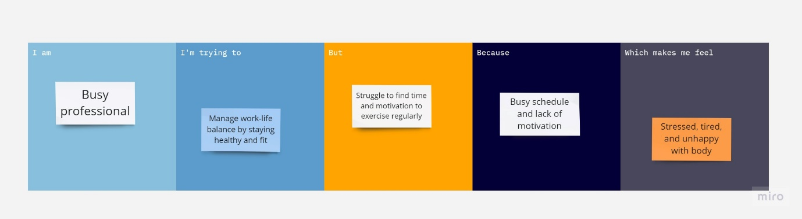

|  |  |  |  |  |  |
| --- | --- | --- | --- | --- | --- |
| **Problem Statement (PS)** | **I am (Customer)** | **I’m trying to** | **But** | **Because** | **Which makes me feel** |
| PS-1 | Busy professional | Manage work-life balance by staying healthy and fit | Struggle to find time and motivation to exercise regularly | Busy schedule and lack of motivation | Stressed, tired, and unhappy with body |
| PS-2 | Student | Improve learning and academic performance | Difficulty in concentrating and staying focused while studying | Affects ability to retain information and perform well in exams | Anxious, overwhelmed, and frustrated with self |